GROUP NAME: ???

PROJECT: MUSIC INFORMATION AND RATING MANAGEMENT SYSTEM

GROUP MEMBERS

1. Emmanuel Victor Kamya
2. Kevin Harmer
3. Eamon Gallagher

DATABASE OBJECTS

Entities

1. songs: Includes song_id, song_name, overall_rating for the song (avg for the song_ratings table), as well as num_ratings (count for this song in the song_ratings table)
2. song_ratings: Each row represents one rating for a song in the songs table. Also includes the user that uploaded the rating. Each song will also have a website rating.
3. users: (Name, address, payment details, subscription package, playlists etc)
4. artists: (Name, record label, albums, songs, # of tours, etc.)
5. album: (Name, Record label, songs, #of promoting tours, etc.)
6. awards and rankings: (list awards given to album, artist or song eg grammys. Rankings can be categorised by genre of album or song).
7. articles: (album review articles, monthly articles on music released that month,
8. Platforms (Type: Spotify, Apple Music, Pandora, etc., number of available songs/artists/albums, App Characteristics, Streams, Reviews, Market Influence Percentage)
9. Music Tour per Artist (start date, end date, number of locations, Estimated Raw Profit, Estimated fans per concert, links for tickets)
10. Estimated Profits (artist, year, album released, single(s) released, Raw Album profit, tour, Raw Tour Profit, Raw Sponsorship Profit, Total Raw Profit),
    1. Optional Expenses with Net Profit (Estimated Record Company Expenses, Estimated Tour Expenses, Band Salaries, Expected Net Profits)

Please post your formalized group and group name here. *The People’s Music*

Also post your topic for your project and also make sure to provide a quick description of your problem.and planned solution in less than 300 words.

*Despite the influence of the music industry on today’s society, there is no centralized system to review the different components of music. While the industry does have places where critics can give their thoughts, there is no real accessible outlet for fans to give their feedback. Our goal is to change that. With today’s technology, people have access to libraries of millions of songs via Spotify, Apple Music, Pandora and other streaming outlets. Concerts tickets are selling out within seconds of their release. Even radio stations are becoming more accessible to their audiences.*

*With all of these people listening to their favorite kinds of music, it is surprising that music streaming services have not yet adopted a system to take their listener’s feedback. Our goal is to do just that. We plan to design a database that links listeners and their ratings to songs, artists, albums, and more. With centralized ratings, the music industry can learn what the public likes and design their content based on their data.*

Please answer the following 4 questions.

Project Background: *Music Ratings and Reviews*

Business Problem: *There is no way for bands, songwriters and record companies to get centralized feedback for their music.*

Proposed Solution: *We will design a database that allows users to rate all different aspects of the music industry. This can potentially include songs, artists, albums, record companies, tours, genres and more.*

5 Potential Entities: *Songs, Ratings, Genres, Users, Albums, Artists, Labels*

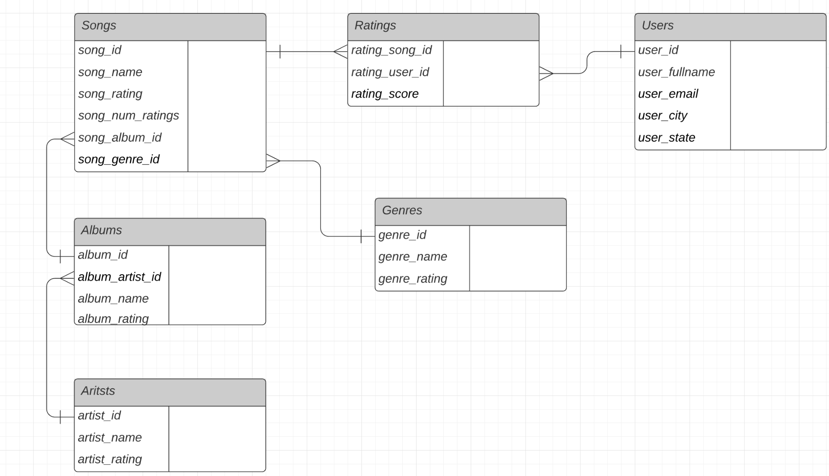

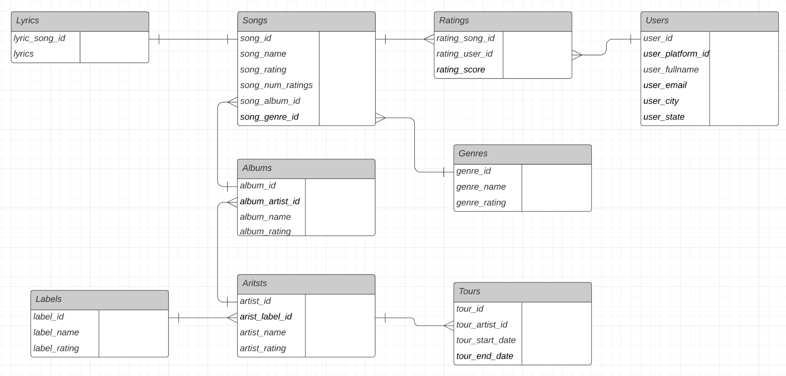

**Checklist (red = need to do; green = done):**

* Document with team name, group members, and project report to submit
* E-R Requirements Sheet: Description and Analysis of entities, attributes, adn relationships in the data model
* Conceptual Data Model
* Logical Data Model
* Layout of Application Screens (WireFrames)
* Diagram with Connecting Application Screens
* Tables Up/Down Script
* Up/Down Script Data
* Identification of External Data Model and Data Logic
* Application Data (user and user ratings data)
* Application Implementation
* User Story incorporated into database application (5.1 on Project Discussion)
* Presentation (Powerpoint?)
* Reflection: What we learned, what we could do better, what could explore with more time, etc.

**Things that could have been added with more time:**

* Featuring artist column in songs table
* Option in Application to add artists, albums and songs
* passwords for powerapp; this will eliminate need for user input in ratings
* social media groups of recommendations
* add album, artist, and genre information into song rating list

**References:**

* Wikipedia (song lengths)